Impact-diamonds Discovered in Greenland Ice Sheet within Younger Dryas Boundary Layer

[Description] Surface and trench samples from the Greenland ice sheet margin reveal an abundance spike of nanodiamonds and other cosmic impact-related material near the onset of the Younger Dryas cold period at 12.9 ka.

Andrei V. Kurbatov ¹, Paul A. Mayewski¹,
REMAINING AUTHOR ORDER NEEDS TO BE DETERMINED. Douglas Cap Introne¹, Sharon B. Sneed¹, Mike Handley¹, Allen West², Ted Bunch³, James Wittke³, Doug Hamilton⁴, Douglas Kennett⁷, James Kennett⁵ Chris Mercer⁸, Jørgen Peder Steffensen⁹, Shane S. Q. Hee??, Wendy Wolbach??, Marilee Sellers??³, James Weaver??

1. Climate Change Institute, University of Maine, Orono, ME, 04473
2. GeoScience Consulting, Dewey, AZ, 86327
3. Dept. of Geology, Northern Arizona University
4. PBS, NOVA
5. Dept. of Earth Science, Univ. of California, Santa Barbara, CA, 93106
6. University of Oregon
7. Japan
8. Centre for Ice and Climate, Niels Bohr Institute, University of Copenhagen

[ABSTRACT—125 words] Analyses of deglacial ice from western Greenland reveal an extraordinary abundance of nanodiamond and carbon spherules in a thin layer of apparent Younger Dryas age. These are the first free diamonds reported from any ice sheet, and they suggest an origin through cosmic impact. Precise age determination is hindered by ice deformation, but a 12.9-ka date is consistent with other Greenland sites. The diamond-rich layer is correlative with YDB layers previously reported in North American sediments. We indentified five diamond allotropes, including lonsdaleite, which is widely accepted as a cosmic impact-indicator. Diamond abundances for YD ice are comparable to those found in Cretaceous-Tertiary (K/T) impact ejecta. If confirmed, this cosmic event complicates use of YD climate forcing as an analog for other climate change events.

[≈280 words above]

Introduction. The Greenland ice sheet has recently received much attention due to its contribution to modern sea level rise and because of the potential impact of meltwater on thermohaline circulation (Stearns). Climate reconstructions using central Greenland ice core records led to the discovery of abrupt, major late Quaternary climatic changes (less than a decade), which, once initiated, persisted for decades and longer (Johnsen; Mayewski). One such event was the Younger Dryas (YD), a 1300-year-long interval during which deglaciation in the Northern Hemisphere paused at 12.9 ka and climate reverted to near-glacial conditions. This cooling is enigmatic because it took place at the peak of Northern Hemispheric solar insolation, and as a result, researchers still disagree as to its cause (Broecker). Recently, at multiple locations across North America, scientists discovered distinct abundance peaks in inferred cosmic impact markers, including nanometer-sized diamonds, magnetic microspherules, and carbon spherules (CS), restricted to a thin sediment layer called the YD boundary layer (YDB) that dates to the YD onset (Firestone, Kennett). They proposed that this impact event may have triggered the YD cooling through major atmospheric changes and by suddenly diverting continental ice sheet meltwater flow into the North Atlantic, severely weakening thermohaline circulation. This hypothesis also posits that the cosmic impact caused other major environmental changes that triggered the extinction of the North American megafauna (e.g., horses, camels, mammoths, mastodon, ground sloths, and short-faced bears) and led to the termination of the Clovis culture. Opponents of the YDB impact hypothesis question the apparent lack of a crater with shocked minerals and speculate that the reported markers result from the continuous, though variable, accretion of meteoritic ablation products rather than from a major cosmic event (Pinter). The possible connection to a cosmic Impact, if confirmed, makes the YD unique among recent climate change events and may be the only major impact event witnessed by anatomically modern humans.
Because the YDB layer is widely distributed over North America and Western Europe, we predicted its occurrence in the Greenland ice sheet at the onset of the YD cooling, which is well documented in the central Greenland ice cores, GISP2 and GRIP. We reasoned that impact markers, such as nanodiamonds, could be more easily extracted from ice than from more complex terrestrial sediments, and we knew that because of the heavy annual snowfall, the Greenland stratigraphic record is more likely to be continuous.

Sites, Stratigraphy, and Methods. In late 2008, the authors arranged sampling expeditions to Greenland with assistance from PBS’s NOVA, as part of a documentary on the YD impact hypothesis. Previously, investigators working on deglacial sections in western Greenland have identified the YD episode based on oxygen isotopic ratios and dust band stratigraphy (Petrenko; Reeh), but the ice sheet is thinner at the sheet margin than at the center due to compression, stretching, and shearing, all causing the thickness of YD ice to vary unevenly. For example, at GISP2, the YD ice is ≈98 m thick (Alley), while away from central Greenland, six sampling sites (Camp Century, Dye-3, Isunguata, Naesset, Pakitsoq, and Kangerlussuaq) display a YD thickness range of 1 to 50 meters with an average of 12.8 m. Near Kangerlussuaq, the YD is 1 m thick, just as it is at Pakitsoq (Table S1). Consequently, it is unlikely that a complete stratigraphic record is preserved at any site along Greenland’s margin, and yet, in spite of some ice deformation, all sites have recognizable stratigraphy.
We selected a sampling site at Kangerlussuaq ≈1 km inland from the present ice margin and near two locations previously studied by Reeh et al. (REF#). One of those sites, Naesset, is 330 meters away from the Kangerlussuaq site, and the other, Isunguata, is 5.9 km away. At both, Reeh encountered the last 20 kyrs of ice exposed by ablation during the melt season with the glacial-postglacial boundary easily identifiable (Fig. S1-S2). The ice that formed during cold glacial times appears as a monolithic, dust-enriched section tens to hundreds of meters thick and can be visually differentiated from clearer, whiter ice of warmer climate episodes, such as the Bølling-Ållerød (B-A), which began 14.5 ka, and the Holocene, which began ≈11.6 ka. The YD section, filled with higher concentrations of wind-blown dust and salts during colder times between 12.9 and 11.6 ka, is sandwiched between clearer, whiter ice deposited during two warming episodes (the B-A and Holocene) and shows no evidence of shearing or folding (Reeh; Petrenko; Fig. 1; Fig. S3).
In the polar ice sheets, isotopic ratios of oxygen-18 to oxygen-16 (δ¹⁸O) are proxies for past atmospheric temperatures, so that low δ¹⁸O values are used to identify ice that formed during the colder YD. For the six sites mentioned above, including nearby Naesset and Isunguata, YD δ¹⁸O values range from -31.0 to -39.0 with a mean of -34.9. At Kangerlussuaq, we acquired presumed YD δ¹⁸O values of -33.3, near the mean of the six sites. For the glacial period, the six sites showed a range of -33.0 to -42.0 with a mean of -36.5, and Kangerlussuaq’s value of -34.9 was near the mean value. Holocene values were similar. Thus, those isotopic values suggest that we have correctly identified the YD ice at Kangerlussuaq (Figs. 2 and S4; Table S1).
As with any sampling site, disadvantages exist for Greenland’s margin: A) deformation of the ice layers can mean that many meters of ice are missing; B) in addition, the ice front retreats rapidly during summer with ice ablation leaving dust concentrations on the surface which move downslope, blurring the stratigraphy; C) for some analyses, we required large quantities of dust particulates, which were sampled from the surface, leading to the possibility of modern contamination and accentuating downslope mixing; and D) we were able to sample only at moderate resolution of 50 to 100 years. Given the difficulties, the true test was the presence of YDB markers. If there was a continuous record and if we had correctly identified the YDB ice layer, then peaks in markers would be apparent, thus providing support for the YD impact hypothesis.
At Kangerlussuaq, we excavated a trench across end-glacial ice, including a 1-meter-thick section of apparent YD ice (Fig. 1). We sampled continuously every 20 cm for 17 m at 20-30 cm depth, collecting 250 to 500 mL of ice in clean plastic bags and bottles for analyses in stratigraphic context of dust particles, water oxygen isotopic ratios, and ice chemistry. Surface samples also were collected directly adjacent to the trench at a stratigraphic resolution of 15 cm. Individual samples in all sequences were estimated to represent 50 to 100 years of deposition. Our goal was to collect continuous samples of ice from the end of the last glacial episode to the early Holocene, across the 1,300-year YD episode.
After sampling the ice, we transported it to the University of Maine, where δ¹⁸O and chemistry values were acquired using the protocol of ???? (ANDREI AND PAUL FILL IN). Based on the δ¹⁸O values, which appeared to confirm the YD interval, we dehydrated selected samples and measured dust content by weighing, extracted CS by filtration and flotation, and removed the magnetic fraction with a neodymium magnet (SUPP-Methods). We extracted the diamonds using a variation of a standard method developed by Huss and Lewis (REF#), which was simplified because of the low abundances of quartz and other minerals that obviated the need for some reagents, such as hydrofluoric acid. Previously, we had discovered that phosphoric and chromic acids destroyed all diamond allotropes except cubics, and thus, we avoided them. Extracts were variously analyzed by inductively coupled plasma-mass spectrometer (MS-ICP), scanning electron microscopy with electron dispersive spectroscopy (SEM-EDS), transmission electron microscopy (TEM), scanning TEM (STEM), and high-resolution TEM (HRTEM). We performed TEM and HRTEM analyses of crystallite sizes and distribution density in order to determine diamond abundances, spending the same amount of analytical time on YDB as non-YDB samples. However, due to small sample sizes and other technical constraints, abundances are semi-quantitative estimates with uncertainties of about an order of magnitude (SUPP-Methods).

Diamonds in Ice. Kennett and colleagues (REF#) reported the presence of abundant diamonds (cubic and n-diamonds), which are proposed to be of impact origin, at six widely separated sites in North America in YD sediment, but not above or below that layer. Now, analytical work performed at four laboratories (University of Maine; University of California, Santa Barbara; University of Oregon; and Northern Arizona University) has confirmed the presence of cubic diamonds in the Greenland YDB ice layer (Fig. 3A; Table S2). This work includes HRTEM measurements and TEM selected area diffraction patterns that detect crystal lattice spacings that are uniquely attributable to cubic diamonds (Fig. 4). Analysis by SEM-EDS confirmed that the diamond crystallites are dominantly carbon. The formation of cubic diamonds typically requires anomalously high temperatures of 1000° to 1700°C and pressures of 5 to 7 GPa (1 million psi), conditions that are nonexistent at Earth’s surface. However, they are common ≈180 km deep where terrestrial diamonds form (Haggerty) and common in cosmic impacts. We also have discovered and confirmed the presence of three other diamond-like polymorphs, n-diamond, p-diamond and i-carbon, the last two of which are previously unknown outside of the laboratory where they were artificially produced under extreme temperature-pressure conditions that are unknown naturally at Earth’s surface (Kleiman).
The four nanometer-sized diamond polymorphs have similar sizes ranging from ≈1 to 500 nm with most averaging 2 to 10 nm. All are similar in transparency and hardness within a few percent, but vary in shape from angular (cubic diamonds) to rounded (n-diamond, p-diamond, i-carbon). Kleiman et al. (REF#) proposed that n-diamond, p-diamond, and i-carbon are simply metastable variants of cubic diamonds, possessing lattices that developed flaws during rapid quenching due to the inclusion of elemental impurities, such as hydrogen, nitrogen, and silicon (Figs. 3-4, S5-S8). We estimate there to be a total of 5 to 50 ppb of cubics, n-diamonds, p-diamonds, and i-carbon, equivalent to 1.4 to 14 billion cm⁻³. This value falls at the lower range of 10 to 3700 ppb estimated from other YDB sites (Kennett) from California to the Carolinas (Fig. S10). If the YDB diamonds are uniformly distributed across North America and Greenland at ≈50 ppb, their total estimated mass exceeds ≈400 metric tons in North American sediments and ≈50 metric tons in Greenland’s YDB ice.
Most importantly, we report the presence of lonsdaleite (hexagonal diamond) as a member of the diamond assemblage in the Greenland YDB ice layer. We detected no lonsdaleite above that layer, but low levels were detected in lower adjacent layers, possibly due to ice ablation. Hexagonal diamonds are known to form only at high temperatures of 1000° to 1700°C with pressures of more than 15 GPa (2 million psi) followed by rapid quenching (DeCarli). Lonsdaleite has never been found associated with terrestrial diamonds (DeCarli), having previously been found on Earth only inside fallen meteorites (Hanneman) and associated with impact craters (DeCarli). Recently, lonsdaleite and other diamond allotropes also have been reported in the K/T impact layer (Bunch). Thus, the presence of lonsdaleite is considered a definitive indicator of high-temperature-high-pressure cosmic impacts (DeCarli).
The Greenland lonsdaleite varies from ≈20 to 500 nm in diameter with most at the lower end of that range. Identified by TEM and HRTEM according to its characteristic lattice spacings (Fig. 5), the lonsdaleite generally manifests as single crystals that appear irregularly subrounded in shape, similar to some lonsdaleite crystallites from Popigai crater (Köeberl). They are abundant in the YDB section, but less so than other polytypes. The estimated relative allotropic abundances in all layers analyzed in Greenland ice are a factor of 1000 for i-carbon, 100 for n-diamond, 10 for cubics, and 1 for lonsdaleite and p-diamond. Estimated YDB lonsdaleite abundances range from ≈100,000 to 1,000,000 cm⁻³.
Our analysis of the Greenland sequence also revealed low background concentrations of nanodiamonds in fifteen non-YDB ice samples spanning an interval of ≈7,000 years (Table S2). We detected no lonsdaleite, p-diamonds, or i-carbon within the ≈5,000 years of ice deposited after the YD onset. However, we found low concentrations of cubics and n-diamonds above the YDB and found all polytypes intermittently at low concentrations below the YDB. The presence of these diamonds, especially those near the YDB, may be due to redeposition of YDB diamonds during ice ablation, but most probably represent meteoritic debris unrelated to the YDB impact. The average background of non-YDB diamonds in ≈7,000 years of Greenland samples, each of similar duration, ranges from 0.000 to 0.098 ppt and averages 0.01 ppt, which is lower than in the YDB layer by a factor of 270,000 (Table S2). This supports the YDB as a major cosmic impact event at 12.9 ka, and it argues strongly that the YDB diamonds are not the result of the normal, non-catastrophic influx of meteoritic material.
Impact-diamonds also have been found in the target rock of 14 terrestrial craters, including Gardnos (Norway), Popigai (Russia), Ries (Germany), Sudbury (Canada), and Zapadnaya (Ukraine), in abundances ranging from 12 to 700 ppb. The YDB upper range of diamond abundance (3700 ppb; Gainey, Michigan) is higher than those craters by a factor of 5 to 40 (Table S4). However, the comparison is not exact since YDB diamonds occur in thin ejecta layers rather than in thick target-rock layers. The upper limit for YDB diamonds also is higher by a factor of 370 than that reported for some meteorites (Huss). Researchers also have detected diamonds in K/T impact ejecta (Carlisle; Hough; Bunch), in which the lower range of K/T diamond abundance (3200 ppb) overlaps the upper range of YDB ejecta diamonds (3700 ppb). This comparison of abundances suggests that the YDB event is comparable to other known impacts, though less energetic than the K/T.

Other Evidence.
Dust. After dehydrating the samples to concentrate the dust, a proxy for cold temperatures, we found that the YD interval had one of the highest dust levels in the sequence, supporting other evidence that we had correctly identified ice from the YD cooling episode. Values ranged from 0.6 to 1.74 grams liter⁻¹, with the latter value occurring in a YD-age sample. Chemical analysis of the YDB sample by SEM-EDS revealed iron (30 wt.%), silicon (26 wt.%), aluminum (9 wt.%), calcium (3 wt.%), and oxygen (25 wt.%), indicating high levels of iron, silica, salts, and clays (Table S5). The GISP2 core also displays high levels of dust during YD cooling, where elevated calcium levels were measured (Fig. S4).
Magnetic Grains. The magnetic fraction that was removed from the sequence of dust samples exhibits concentrations ranging from 0.035 to 0.57 grams liter⁻¹. The highest concentration coincides with the YDB and was a factor of 16 above background. For technical reasons, we were unable to adequately test the magnetic fraction for microspherules and iridium, two markers found to peak in the YDB at other sites.
Charcoal. We have yet to analyze these samples for soot either. Other biomass burning proxies, such as charcoal and glass-like carbon, which peak at other YDB sites, were observed in only very low quantities, perhaps because of the distance of the Greenland ice sheet from North America.
Ammonium. In support of impact-related fires at the YD onset, a massive ammonium (NH₄⁺) spike also marks the onset of the YD in the precisely dated GISP2 ice core (Mayewski) (Fig. S4) and in the GRIP ice core (Legrand). The GISP2 ammonium spike is the largest of the last 110,000 years, and at GRIP, it is the largest of the previous 386,000 years. Large ammonium spikes in ice cores, along with peaks in nitrate, formate, acetate, and oxalate, previously have been considered to reflect biomass burning events (Mayeswki; Fuhrer), including for the Tunguska airburst in 1908 (Taylor).
Carbon Spherules. From the YDB and adjacent Greenland ice layers, we recovered CS, which are charred, amorphous-carbon spheres produced during intense wildfires. They formed a wide abundance peak spanning several samples downslope, perhaps due to ice ablation. Their abundance equals 640 liter⁻¹ (Fig. 3 and S9; Table S2), higher than most other YDB sites that had a mean of 489 kg⁻¹. However, they are typically smaller (0.5 to 40 microns) than at other YDB sites, where they average 0.15 to 2.5 mm. We propose that their smaller size is due to longer-distance transport through the atmosphere from their formation site, most likely North America. The presence of CS in Greenland ice represents further evidence supporting widespread biomass burning at the YD onset and supports the identification of this layer as the YDB.
Nanodiamonds are reported inside CS (Kennett), and we demonstrated in laboratory experiments that carbon-encapsulated n-diamonds form only at high temperatures (>850°C) in a low-oxygen atmosphere, since n-diamonds and CS are combustible from ≈600° to 800°C at normal atmospheric oxygen concentrations. Such conditions are known to exist naturally only during cosmic impacts or airbursts. By reverse-engineering YDB impact conditions, we were able to understand the diamond formation sequence, and this led to a patent application for a unique, new process of diamond synthesis.
Our experiments suggest that many of the CS and YDB diamonds formed as a result of impact-related biomass burning, but a small percentage of CS and diamonds may have arrived inside the impactor fragments if they were carbon-rich. On the other hand, some YDB CS may have formed during impacts into carbon-rich target rocks, such as carbonate or coal. In the K/T boundary, Harvey and others (REF#) discovered CS that are identical to YDB CS in morphology and size (1 to 60 μm; mean 6.1 μm) (Fig. 3E). Those authors proposed that the CS formed during impact into carbon-rich K/T rocks, and Hough et al. (REF#) concluded separately that the K/T diamonds formed the same way. Experiments with NASA’s hypervelocity vertical gun demonstrated that projectiles fired into carbonate rock produced solid CS, as well as hollow CS, called calabashes, that are morphologically identical to YDB CS and that range in size from 45 to 308 nm with a mean of 114 nm (Rietmeijer), at the lower end of the range of YDB CS sizes. Thus, it is well demonstrated that both CS and diamonds are closely connected to impacts.
To account for the massive amount of YDB CS and diamonds (hundreds of metric tons), we propose that the YD event involved large numbers of cosmic impactors, most of which created airbursts, but some of which impacted the ice sheet and/or oceans. Such a scenario could have resulted from a rubble-pile asteroid or a fragmented comet that disintegrated into multiple pieces long before encountering Earth’s atmosphere (see image and discussion of Comet Schwassmann-Wachmann at Fig. S11). If so, then, since lonsdaleite cannot form at the lower pressures generated by an airburst (<1 GPa), there are two possibilities: either the cosmic fragments carried lonsdaleite inside them or some cosmic fragments impacted the ground, ice sheets, or oceans. Based on frequency distributions of YDB evidence, a likely site for such impacts was the Laurentide Ice Sheet in east-central Canada, where extensive deposits of carbonate rock once lay buried beneath the ≈3-km-thick Laurentide ice sheet. Using NASA’s hypervelocity vertical gun, Schultz (Firestone) conducted experiments, which indicated that, under favorable conditions, large impactor fragments could have penetrated the 3-km-thick ice and left no classically recognizable impact traces beneath. Comets capable of producing the YD event are common—astronomers have discovered forty such fragmented comets in the last 150 years, for an average of about one every four years (Boehnhardt).

Future work. Further sample collections in Greenland are required for analyses of material at higher temporal resolution (years rather than a century) that may have formed through cosmic impact and related biomass burning associated with the YDB. This includes ammonium, iridium, magnetic spherules and grains, soot, platinum, and osmium.

Summary.
We have discovered nanodiamonds in the Greenland ice sheet represented by a narrow high abundance peak (5 to 50 ppb) at or close to the onset of the Younger Dryas cool episode, representing the first report of free diamonds in glacial ice on Earth. Determination of precise age of the diamond layer is hindered by ice deformation along the ice sheet margin, but an age of 12.9 ka appears likely based on lithostratigraphic analyses of dust concentrations and oxygen isotopic ratios. Identification of diamonds is confirmed using multiple approaches (TEM, SEM, and HRTEM), revealing a diverse, abundant diamond population consisting of cubic and lonsdaleite allotropes, in addition to n-diamonds, p-diamonds, and i-carbon. The Greenland nanodiamond layer is correlative to the diamond-rich YDB layer (12.9 ka) reported in sediments of North America and Western Europe based on abundance peaks in a similar nanodiamond assemblage, along with carbon spherules and magnetic grains. At some YDB sites, diamonds have been found encapsulated within CS, having formed abruptly in situ. Collectively, this evidence strongly refutes speculation that the peak abundances in nanodiamonds in the YDB layer in Greenland ice and terrestrial sediments simply resulted from the accumulation of meteoritic materials over time. The presence of lonsdaleite in the Greenland ice is the first definitive evidence for shocked impact minerals in the YDB layer. Because of the high temperatures and pressures needed to form the diamonds, we suggest that the YDB diamond assemblage in Greenland ice and elsewhere could not have formed under typical conditions at the Earth's surface, and instead, the diamonds provide strong support for the YDB layer having formed through cosmic impact and related biomass burning. The YDB layer in Greenland also appears to correlate with abrupt onset of a previously reported major peak in ammonium and other organic chemicals considered as proxies for massive biomass burning, an interpretation also consistent with a cosmic impact event at that time. Given the geographic isolation of the Greenland ice sheet, the massive abundance of YDB diamonds and CS indicates long-distance transport through the atmosphere. In turn, this implies the presence of a nanodiamond-rich datum of 12.9 ka age over broad areas of the Northern Hemisphere and perhaps beyond. This layer, already documented at various sites across North America, Greenland, and Western Europe should serve as valuable datum for long-distance correlation and age control of sediments. If this cosmic impact is confirmed to coincide with and to have triggered the abrupt onset of the YD cooling episode, it complicates the use of the YD as an analogue for past abrupt climate change.
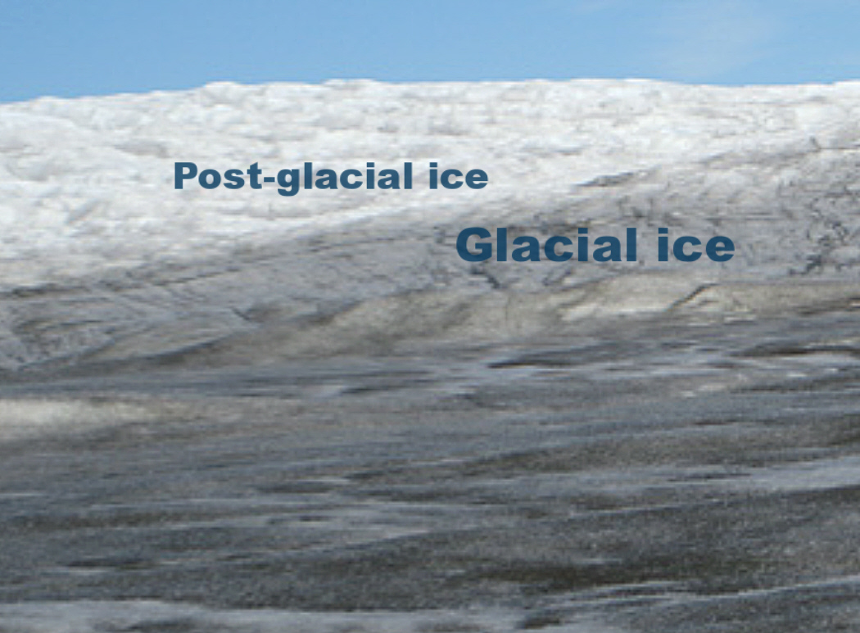
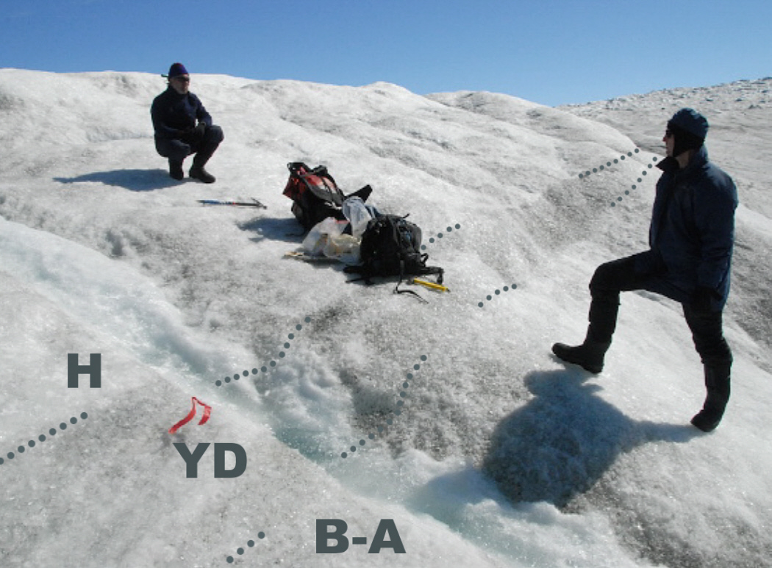

Fig. 1: Left, view of ice margin on the way to the Kangerlussuaq site. The contrast between the two intervals is clearly exhibited in the photos and represents a lithostratigraphic base for recognizing Termination 1A in the B-A 14.5 ka, the onset of major deglaciation. Right, the Kangerlussuaq trench across dustier YD ice, between clearer, whiter ice from the warmer Holocene (H) and B-A.

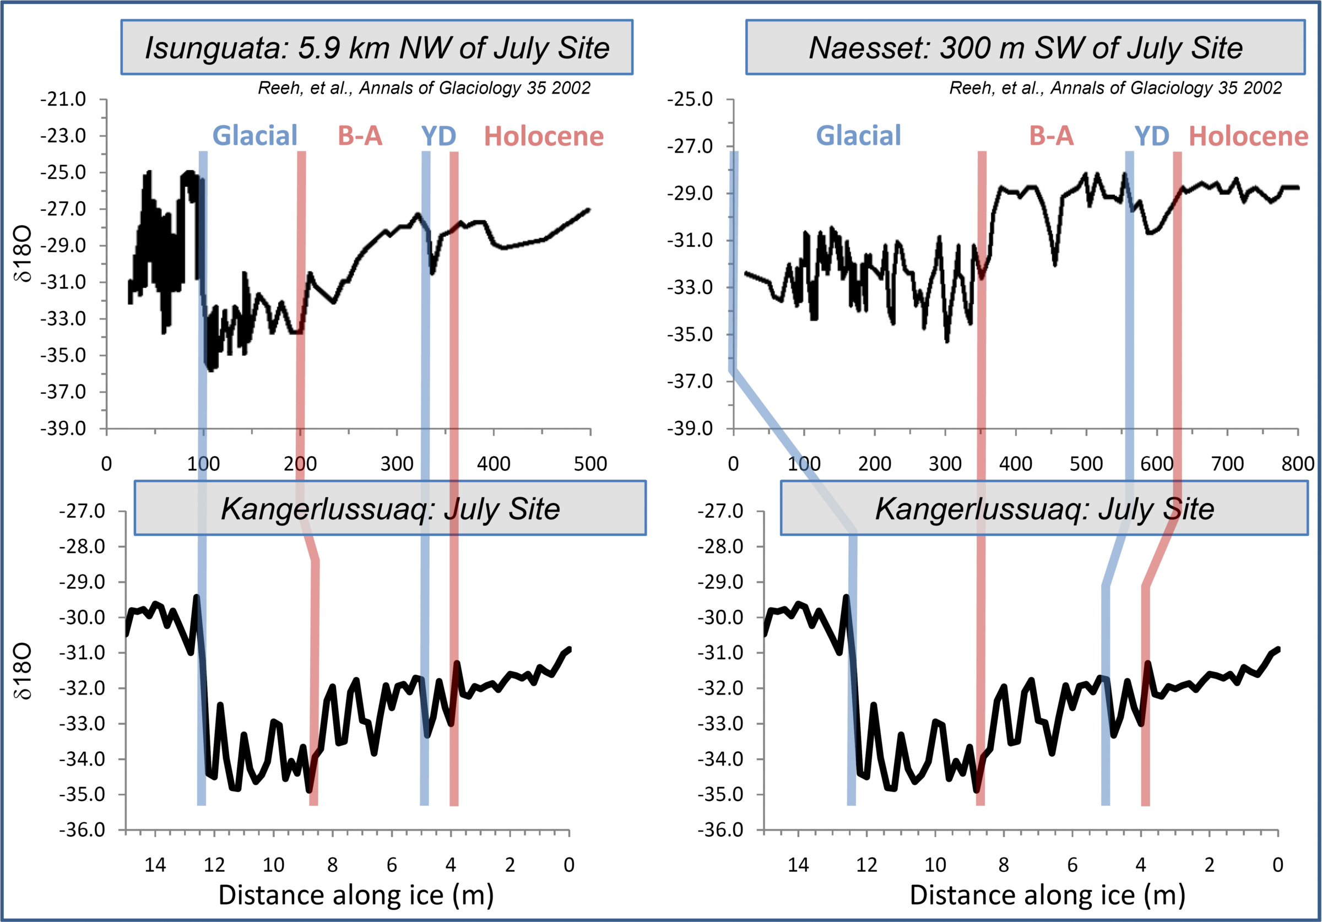
Fig. 2. Comparison of oxygen isotopic records between Kangerlussuaq (lower) and nearby Isunguata (upper left) and Naesset (upper right) sites as reported by Reeh. Boundaries are indicated that separate Glacial and B-A (Termination 1A) and the upper and lower boundaries of the Younger Dryas cooling episode.

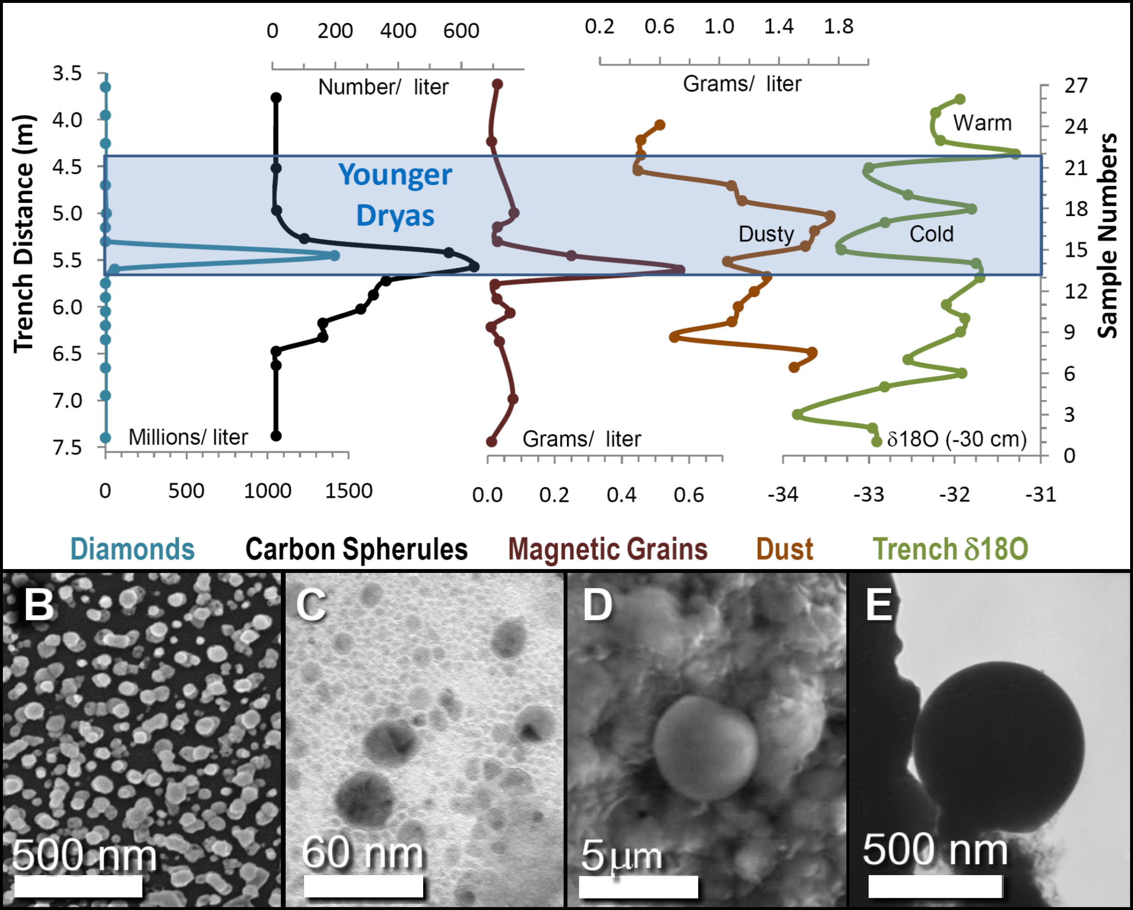

Fig. 3: A) Graph showing that nanodiamonds, CS, magnetic grains, dust, and δ¹⁸O all peak in the YD. B) SEM image of dozens of nanodiamonds; C) STEM image of i-carbon and lonsdaleite; D) SEM of 4-micron carbon spherule; and E) TEM of 500-nm carbon spherule. (Table S2-S3)

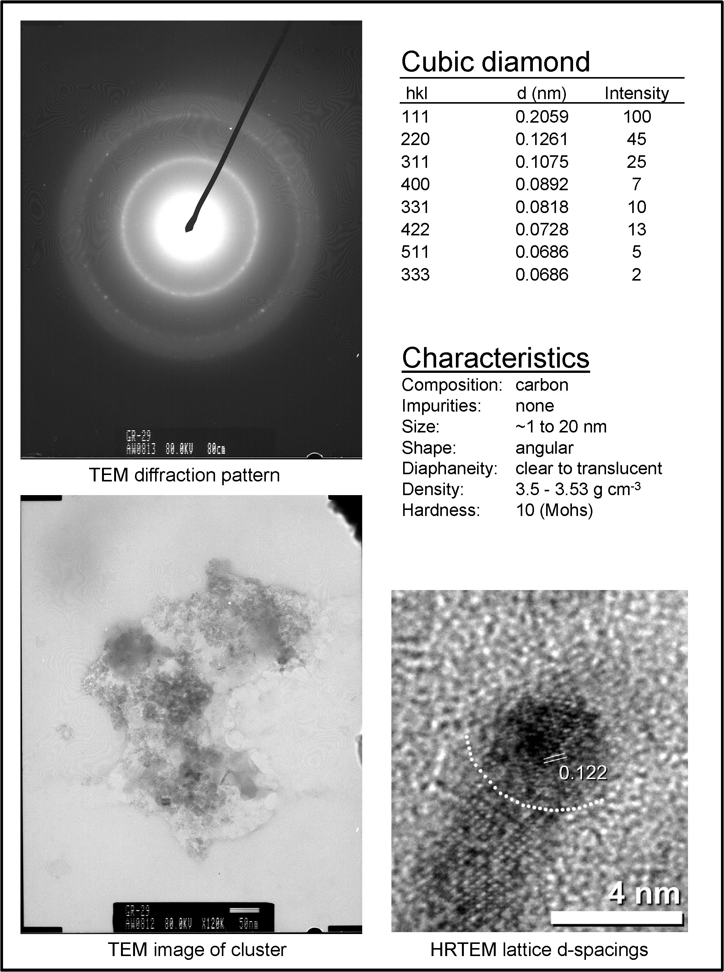
DOUG: NEED BETTER HRTEM FOR CUBIC
Fig. 4. Cubic diamond information.
--CROP ALL IMAGE LEGENDS TO COMPRESS

--STATE WHERE SAMPLE FROM FOR EACH OF DIAMOND TYPES

--SIZE SCALE ON TEM IS NOT CLEAR

--BEST TO STATE THAT EACH IMAGE IS FOR A DIFFERENT CRYSTAL;

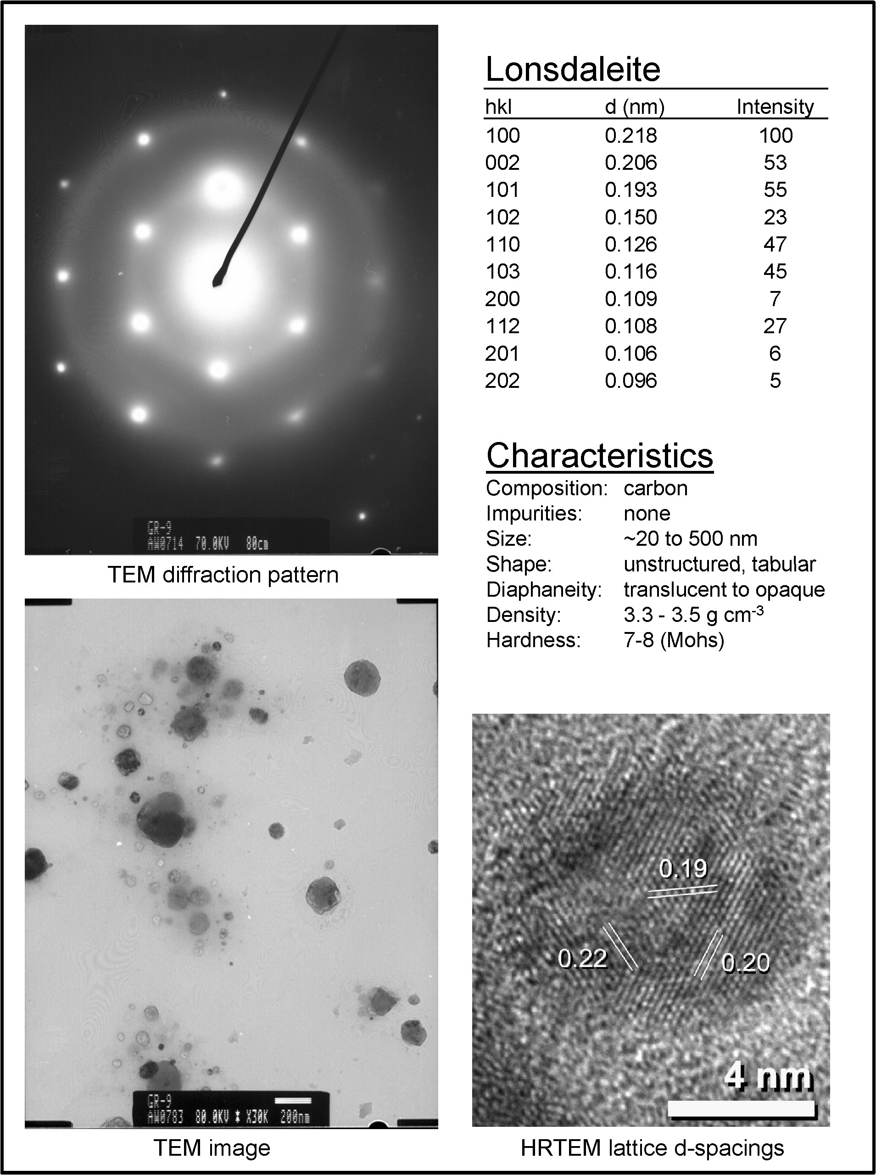
BOLD #S
Fig. 5. Hex diamond information..

--ADD D-SPACING LABELS OF LINES
--DOUG, CAN YOU IMAGE A SINGLE CRYSAL??

--ONE MORE IMAGE; ADD MORE IMAGES OF DIAMONDS??

[REFERENCES (40); et al. with more than 5 authors.]

Alley, R.B., et al 1997. Journal of Geophysical Research 102:26367-26381
Boehnhardt, H. Comets II, M. C. Festou, H. U. Keller, and H. A. Weaver (eds.), University of Arizona Press, Tucson, 745 pp., p.301-316, 2004
Wallace S. Broecker, et al. Nature 341, 318 - 321, 1989
Bunch, T. E. et al. American Geophysical Union, Fall Meeting 2008, abstract #PP13C-1476
T. H. Burbine, Bulletin of the Czech Geological Survey, Vol. 77, No. 4, 243–252, 2002
B. C. Carlisle, R. B. Braman, Nature, v. 352, p. 708–709 (1991).
Gareth S. Collins, H. Jay Melosh, Robert A. Marcus. Meteoritics & Planetary Science 40, Nr 6, 817–840 (2005); Impact Calculator: http://www.lpl.arizona.edu/impacteffects/
P. S. DeCarli, E. Bowden, A. P. Jones, G. D. Price, In C. Koeberl, K. MacLeod, Eds., Catastrophic Events and Mass Extinctions: Impacts and Beyond (Geological Society of America Special Paper 356, Boulder, CO, 2002), p. 595-605.
R. B. Firestone et al., Proc. Natl. Acad. Sci. 104,16016 (2007).
Fuhrer, K., and M. Legrand (1997), J. Geophys. Res., 102(C12), 26,735–26,745.
S.E. Haggerty, Science Vol 285 1999.
R. E. Hanneman, H. M. Strong, F. P. Bundy, Science 155: 995-997, (1967).
Mark C. Harvey, Simon C. Brassell, Claire M. Belcher and Alessandro Montanari Geology; 2008; v. 36; no. 5; p. 355-358
Hough, R. M., Gilmour, I., and Pillinger, C. T., 1999, in Dressler, B. O., and Sharpton, V. L., eds., Large Meteorite Impacts and Planetary Evolution II: Boulder, Colorado, Geological Society of America Special Paper 339.
Huss, Gary R.; Lewis, Roy S. Geochimica et Cosmochimica Acta, vol. 59, Issue 1, pp.115-160, 1995
S. J. Johnsen, et al. Nature 359, 311-313 24 09 1992
D. J. Kennett, et al., Science 323: 94 2009
Kleiman, J.; Heimann, R. B.; Hawken, D.; Salansky, N. M. Journal of Applied Physics, Volume 56, Issue 5, September 1, 1984, pp.1440-1454 1984
C. Köeberl, et al., Geology 25: 967-970, (1997).
Legrand, M.; de Angelis, M.; Staffelbach, T.; Neftel, A.; Stauffer, B. Geophysical Research Letters (ISSN 0094-8276), vol. 19, March 3, 1992, p. 473-475. 1992
Mayewski, P. A. et al. Science 261, 195−197 (1993).
Nolan, Michael C. et al. American Astronomical Society, DPS meeting #38, #12.06; Bulletin of the American Astronomical Society, Vol. 38, p.504 2006
Petrenko, V.J. Severinghaus, E. Brook, N. Reeh and H. Schaefer, 2006, Quaternary Science Reviews 25 (2006) 865–875
Pinter N,; Ishman SE. (2008) GSA Today 18:37–38.
N Reeh, H Oerter, HH Thomsen, Annals of Glaciology 35 2002
Rietmeijer, F.J.M., Schultz, P.H. and Bunch, T.E. (2003) Chem. Phys. Lett., 374, 464-470.
Stearns, L.A. & G.S. Hamilton. 2007.Geophysical Research Letters, 34, L05503,
Taylor KC, Mayewski PA, Twickler MS, Whitlow SI. 1996. The Holocene 6: 1–6.
Z.Q. Yang, et al. Diamond and Related Materials, Volume 17, Issue 6, June 2008, Pages 937-943

